**PIXEL: How to build a new firmware for micoSD card flashing**

1. Build the firmware as normal from MPLABX IDE

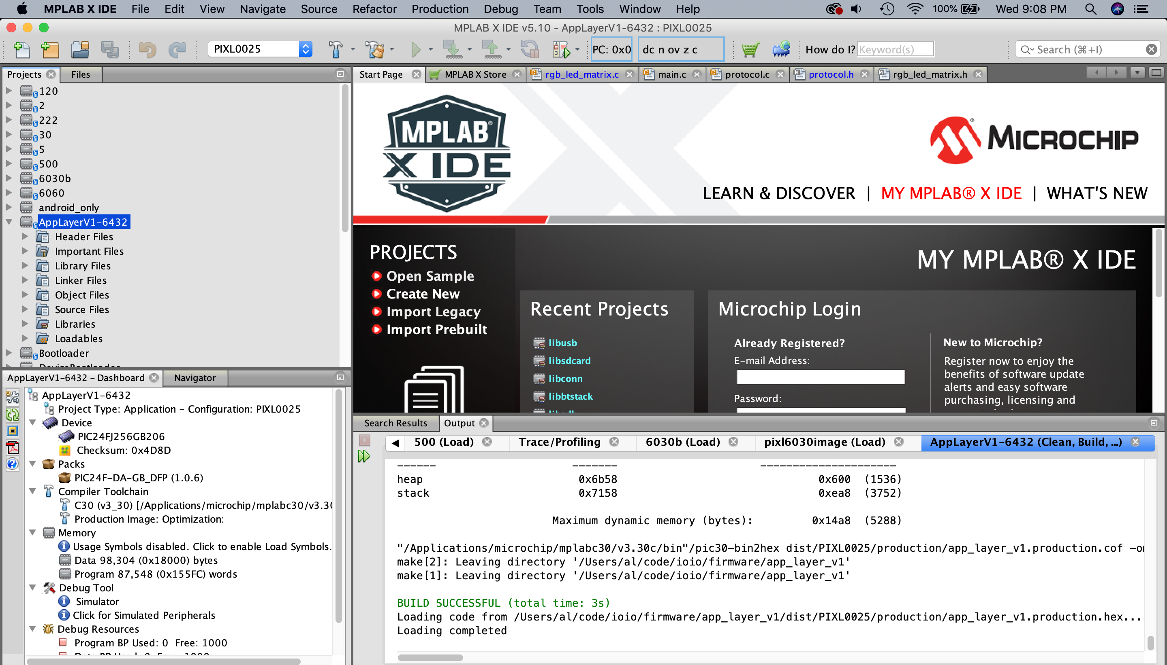

1. Use the hex2ioio command line (located in ioio/tools/hex2ioio) to convert the .hex firmware to a ioio firmware image, rename this file to FW.IMG

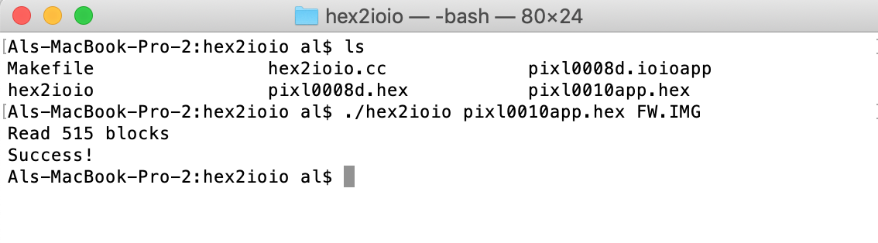

1. Get the MD5 checksum for FW.IMG from <http://onlinemd5.com/>

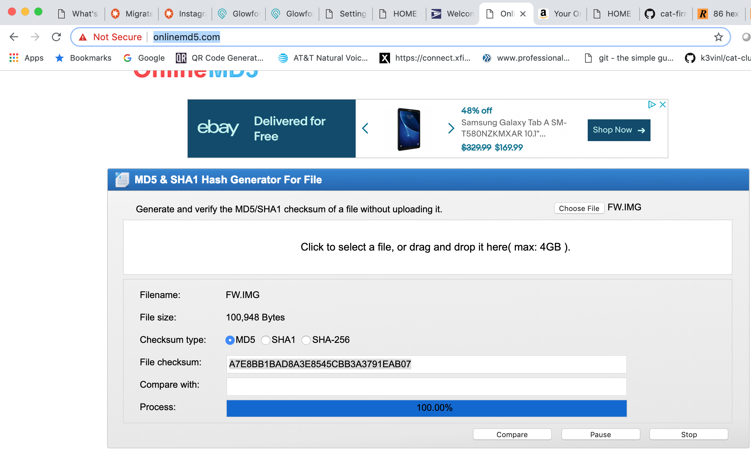

1. Edit FW.HDR with a hex editor like Hex Fiend and replace these numbers with the MD5 checksum



1. Rev these two numbers for a new release. In this example, B2 in hex = 178 in decimal. So use B3 for a new release for example.



1. This is the number of blocks but not sure how / what to put here?



1. That’s it, now just copy FW.IMG and FW.HDR to the microSD card image.